# EXP NO: 04 DATE:

**DESIGN AND IMPLEMENT A DESK CALCULATOR USING THE LEX TOOL**

## Problem Statement

Recognizes whether a given arithmetic expression is valid, using the operators +, -, *, and /. The program should ensure that the expression follows basic arithmetic syntax rules (e.g., proper placement of operators, operands, and parentheses).

# AIM:

To design and implement a Desk Calculator using the LEX tool**,** which validates arithmetic expressions containing **+**, **-**, **\***, **/**, numbers, and parentheses. The program ensures that the expression follows correct arithmetic syntax rules.

# ALGORITHM:

## Start

* Define token patterns in **LEX** for:
  + **Numbers** (integer and floating-point)
  + **Operators** (+, -, *, /)
  + **Parentheses** ((, ))

## Whitespace (to ignore spaces and tabs)

* Read an arithmetic expression as input.
* Use **LEX rules** to identify and validate tokens.
* If an **invalid token** is encountered, print an error message.
* If the expression is valid, print "Valid arithmetic expression."

## End PROGRAM:

%{

#include <stdio.h> #include <stdlib.h>

%}

%%

[0-9]+ { printf("NUMBER: %s\n", yytext); } [+\-*/] { printf("OPERATOR: %s\n", yytext); } [\n] { printf("NEWLINE\n"); }

[ \t] { /* Ignore whitespace */ }

. { printf("INVALID CHARACTER: %s\n", yytext); }

%%

int main() {

printf("Enter an expression: "); yylex();

return 0;

}

int yywrap() { return 1;

}

# OUTPUT :

**RESULT:**

|  |  |
| --- | --- |
| **Implementation** |  |
| **Output/Signature** |  |

lex calculator.l cc lex.yy.c -o calculator

./a.out

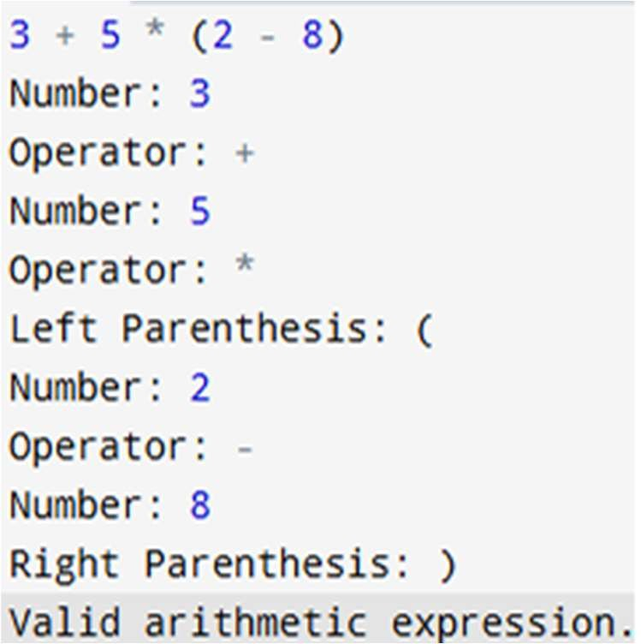

Thus the above program reads an arithmetic expression, tokenizes it using LEX rules, and validates the syntax by recognizing numbers, operators (+, -, *, /), and parentheses. If the expression is valid, it prints "Valid arithmetic expression." Otherwise, it detects and reports invalid tokens